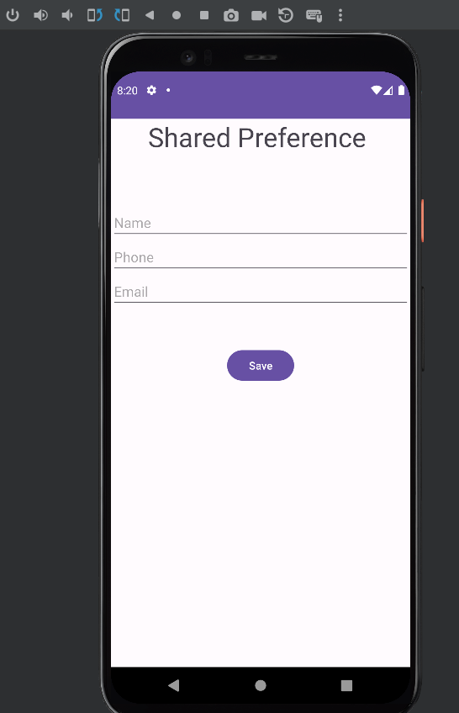

Activitymain.xml:

<?xml version="1.0" encoding="utf-8"?>  
<RelativeLayout xmlns:android="http://schemas.android.com/apk/res/android"  
 xmlns:app="http://schemas.android.com/apk/res-auto"  
 xmlns:tools="http://schemas.android.com/tools"  
 android:layout_width="match_parent"  
 android:layout_height="match_parent"  
 tools:context=".MainActivity"  
 tools:ignore="ExtraText">  
  
 <TextView  
 android:layout_width="wrap_content"  
 android:layout_height="wrap_content"  
 android:text="Shared Preference "  
 android:id="@+id/textView"  
 android:layout_alignParentTop="true"  
 android:layout_centerHorizontal="true"  
 android:textSize="35dp"  
 tools:ignore="HardcodedText,SpUsage" />  
  
 <EditText  
 android:id="@+id/editText1"  
 android:layout_width="wrap_content"  
 android:layout_height="wrap_content"  
 android:layout_below="@+id/textView"  
 android:layout_alignParentStart="true"  
 android:layout_alignParentLeft="true"  
 android:layout_alignParentEnd="true"  
 android:layout_alignParentRight="true"  
 android:layout_marginTop="67dp"  
 android:hint="Name"  
 tools:ignore="HardcodedText,TouchTargetSizeCheck,TouchTargetSizeCheck" />  
  
 <EditText  
 android:layout_width="wrap_content"  
 android:layout_height="wrap_content"  
 android:id="@+id/editText2"  
 android:layout_below="@+id/editText1"  
 android:layout_alignParentLeft="true"  
 android:layout_alignParentStart="true"  
 android:layout_alignParentRight="true"  
 android:layout_alignParentEnd="true"  
 android:hint="Phone"  
 tools:ignore="RtlHardcoded,TextFields" />  
  
 <EditText  
 android:layout_width="wrap_content"  
 android:layout_height="wrap_content"  
 android:id="@+id/editText3"  
 android:layout_below="@+id/editText2"  
 android:layout_alignParentLeft="true"  
 android:layout_alignParentStart="true"  
 android:layout_alignParentRight="true"  
 android:layout_alignParentEnd="true"  
 android:hint="Email"  
 tools:ignore="TextFields" />  
  
 <Button  
 android:layout_width="wrap_content"  
 android:layout_height="wrap_content"  
 android:text="Save"  
 android:id="@+id/button"  
 android:layout_below="@+id/editText3"  
 android:layout_centerHorizontal="true"  
 android:layout_marginTop="50dp"  
 tools:ignore="HardcodedText" />  
  
  
</RelativeLayout>

MainActivity.java

package com.example.myapplicationshared;  
  
import android.annotation.SuppressLint;  
import android.content.Context;  
import android.content.SharedPreferences;  
import android.os.Bundle;  
import android.view.View;  
import android.widget.Button;  
import android.widget.EditText;  
import android.widget.Toast;  
  
import androidx.appcompat.app.AppCompatActivity;  
  
public class MainActivity extends AppCompatActivity {  
 EditText ed1, ed2, ed3;  
 Button b1;  
 String MyPREFERENCES = "MyPrefs";  
 String Name = "nameKey";  
 String Phone = "phoneKey";  
 String Email = "emailKey";  
 SharedPreferences sharedpreferences;  
  
 @SuppressLint("MissingInflatedId")  
 @Override  
 protected void onCreate(Bundle savedInstanceState) {  
 super.onCreate(savedInstanceState);  
 setContentView(R.layout.*activity_main*);  
 ed1 = findViewById(R.id.*editText1*);  
 ed2 = findViewById(R.id.*editText2*);  
 ed3 = findViewById(R.id.*editText3*);  
  
 b1 = findViewById(R.id.*button*);  
 sharedpreferences = getSharedPreferences(MyPREFERENCES, Context.*MODE_PRIVATE*);  
 b1.setOnClickListener(new View.OnClickListener() {  
 public void onClick(View v) {  
 String n = ed1.getText().toString();  
 String ph = ed2.getText().toString();  
 String e = ed3.getText().toString();  
 SharedPreferences.Editor editor = sharedpreferences.edit();  
  
 editor.putString(Name, n);  
 editor.putString(Phone, ph);  
 editor.putString(Email, e);  
 editor.commit();

Toast.*makeText*(MainActivity.this, "Thanks",Toast.*LENGTH_LONG*).show();  
  
  
 }  
 });  
 }  
}

Output:

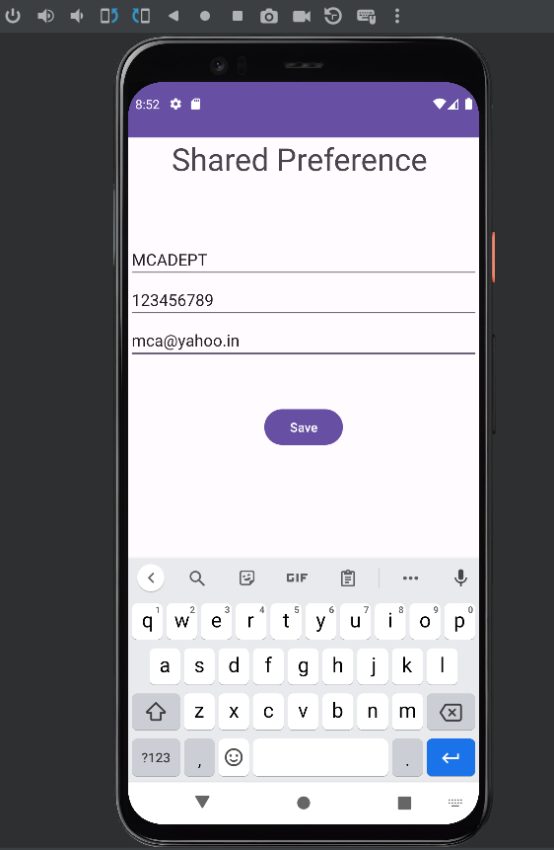

After entering the valid input check in the device explorer

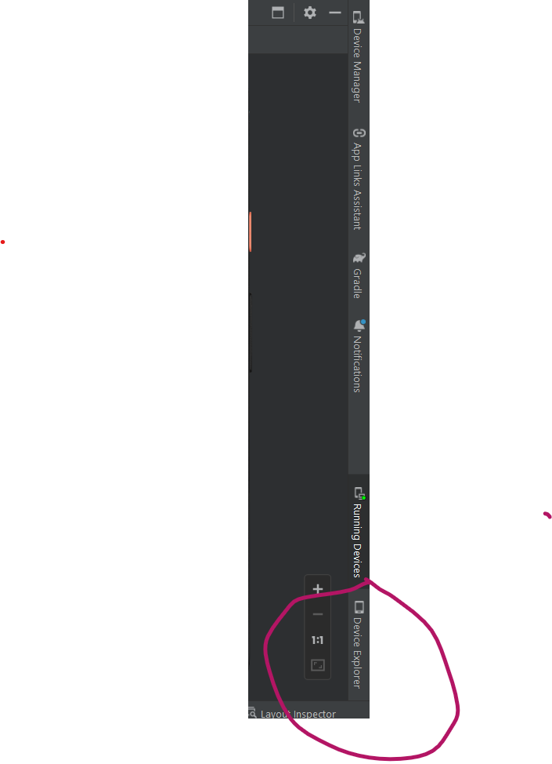

Open the following

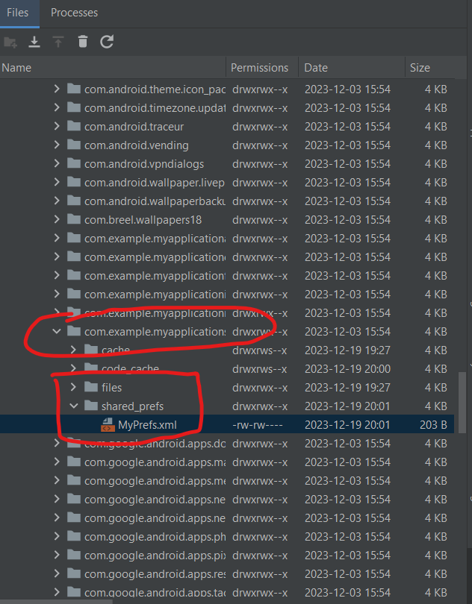

Observe the value

